Mid Term Examinations (Fall 2024) - Solution

Course Code with Title | CS-472: Human Computer Interaction |  | Program | Bachelor of Computer Science BS (CS)
Instructor(s) | Engr. Farhana Ashraf |  | Semester | 7th
Start date & Time | Dec 10, 2024  at 09:30 AM | End Time | 11:00 AM
Maximum Marks | 30
IMPORTANT INSTRUCTIONS:
Read the following Instructions carefully:
- Attempt All Questions.
- Please do mention your section on the top of the answer script.

Q.No.1 | (CLO_1): (Cognitive Level C2, i.e., Understanding) (PLO_2: Knowledge for Solving Computing Problem) (5+5+3 Marks)

- Microsoft tool bars provide the user with the operation of displaying a label below each tool. Keeping in view the ‘Fitt’s Law’, give reasons why labeled tools may be accessed faster. (Assume that the user knows the tool and does not need to identify the label.)
Answer:
Fitt’s law states that: “Users will hit a target faster if it’s big and close to where they start.” Though Microsoft tool bars are tiny in size but as user is already familiar with the tool and does not need to identify the label by placing mouse on an icon he can access it faster. Moreover, this reasoning could also be justified by power aw of practice that states: “user do stuff faster the more they practice’.

Not attempted | Irrelevant answer | Right reasoning | Relate to power law
Zero mark | 1 mark | 4 mark | 1 mark

b) Illustrate a detailed conceptual model of an alarm clock using node-link diagram. Given below are the requirements.

- The clock stores current time of the day and continually updating it to track the passage of time.
- It displays the current time constantly.
- Users can set the current time.
- Users can set an alarm at a specified time, or no alarm.
- When an alarm is set and current time equals to the set alarm time, the alarm is triggered.
- Users can turn off an alarm.

Answer:
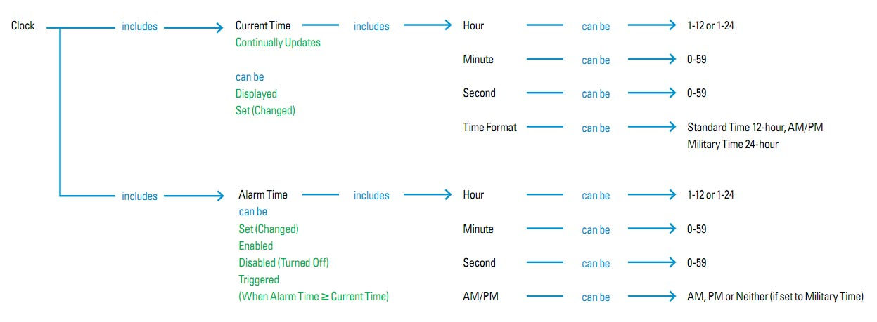
Not attempted | Irrelevant answer | other | Not detailed | detailed
Zero mark | 0 mark | 1-3 marks | 4 marks | 5 marks

c).Observe the following ‘word processing tool bar’ screen shot. Describe any three forms of analogy and composite interface metaphors that have been used in its design. Also explain what familiar knowledge has been combined with the new functionality.


Answer:
Composite Metaphor | Analogy | Familiar Knowledge
Hardboard | Hardboard clip is used to clip a paper | User is already familiar with the hardboard to clip the paper
Scissor | Used for cutting | User is already familiar with the scissor to cut cloths, hair, paper, etc.
Paint brush | Used for painting | User is already familiar with the paint brush for painting walls.

Not attempted | Irrelevant answer | 3 metaphors
Zero mark | zero mark | 3 marks (1*3)

Q.No.2 | (CLO_2): (Cognitive Level C2, i.e., Understanding) (PLO_8: Computing Professionalism and Society) (5+5+5+2 Marks)

- Identify any one wearable wireless gadget that has been wide spread in our society and discuss it’s after-effects on health of the users.
Sample Answer:

Wearable gadget:
- Airpods and Bluetooth Earbuds

After effects on health of the users:
- AirPods and Bluetooth headsets constantly emit radiofrequency (RF) radiation, AKA microwaves while they are in your ears, whether you are using them or not.
- The RF is absorbed into your skull, brain and ear tissues.
- The left AirPod communicates with the right AirPod using a technology called “near field magnetic induction” (NFMI). The fields go right through your brain. Magnetic fields are linked to cancer and oxidative stress.
- Daily use of Bluetooth headsets “strongly linked” to an increased risk of developing thyroid nodules.
- “More than a dozen studies have shown that low-intensity microwave radiation similar to that emitted by Bluetooth can open up the blood-brain barrier, a layer of cells that block pathogens and toxins in the body from reaching the brain. That could lead to conditions such as autism, dementia, and brain cancer.”
- Peer-reviewed research has demonstrated a myriad of adverse effects from wireless RF radiation including increased brain cancer, DNA damage, oxidative stress, immune dysfunction, altered brain development, damaged reproduction, sleep changes, hyperactivity, and memory damage.

Reference:
Airpods and Bluetooth Health and Safety FAQs - Environmental Health Trust

Rubric:
Not attempted | Irrelevant answer | Identify | 4 after effets
Zero mark | 1 mark | 1 mark | 4 marks (1*4)

(b) Read the following excerpt to discuss the significance of the personal experience of users who interact with technology in safety critical domains and express your opinion on how to approach better user experience in ‘safety critical domains’.

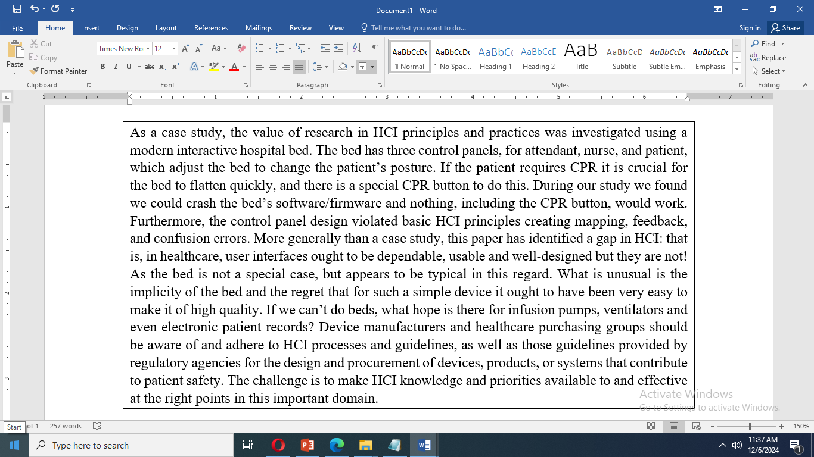

Open ended question Rubric:

Not attempted | Irrelevant answer | Significance | Opinion
Zero mark | 1 mark | 1-2.5 marks | 1-2.5 marks

(c) You have set up early usability tests of a paper prototype with nurses at a medical facility. The test was difficult to schedule because nurses’ time is guarded carefully and marketing carefully guards the relationship with customers. The nursing managers insist on “taking the test” themselves first, and then on being present in the room during the tests with the other participants to “be sure they do it right.” You believe that the managers’ presence will be intimidating to the nurses, altering the results of the test. Do you continue with the usability tests? Defend your opinion.
Sample Answer:

Yes: If you turn down this opportunity to work with users, it might be impossible to set up a test in the future. Although you would have to carefully evaluate the test results for bias caused by the managers, you will still get valuable comments on the concepts in the prototype.

No: Putting the nurses into a situation where they are being asked to react and comment freely in front of their obviously critical managers would be so stressful as to be unethical. You should find a way to avoid running these tests

Not attempted | Irrelevant answer | opinion | Justification
Zero mark | 1 mark | 1 – 2.5 marks | 1 – 2.5 marks

(d) Describe any two complacencies of human beings while working with robots that may lead to injuries.
Answer:
- Warning signals that a robot arm is moving should not be present continuously because humans quickly become insensitive to constant stimuli.
- Humans also commonly make mistaken assumptions about robot movements.

Not attempted | Irrelevant answer | Constant stimuli | Making assumptions
Zero mark | Zero mark | 1 mark | 1 mark

